
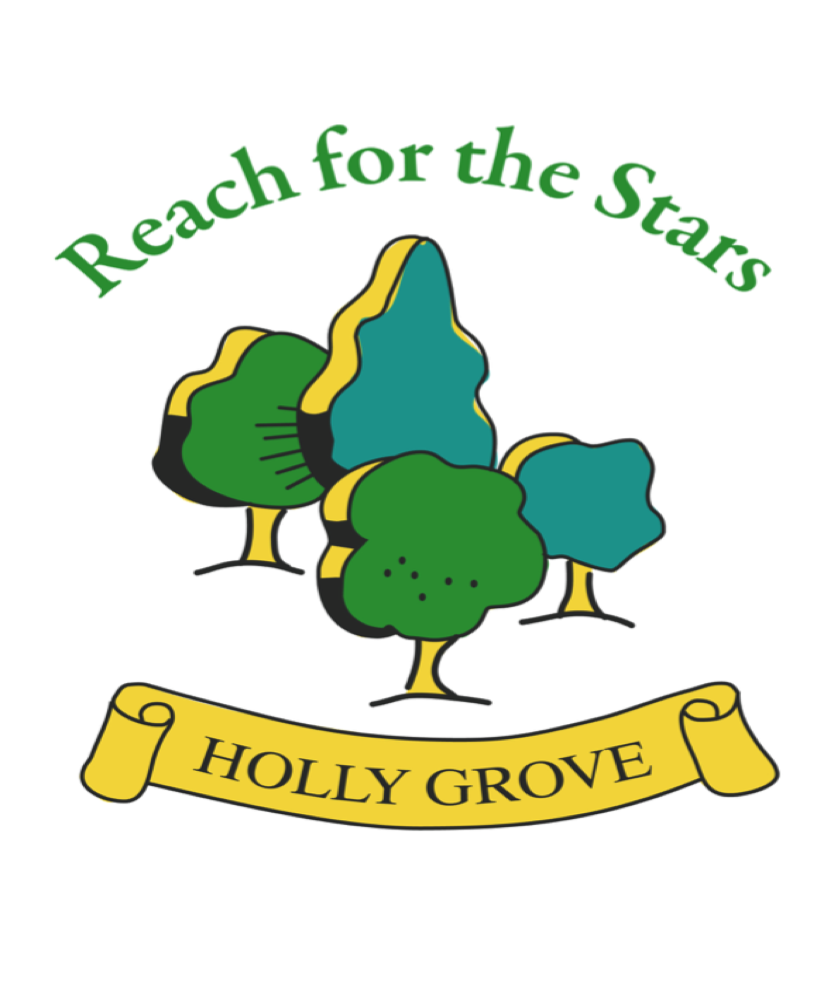
24th January 2024
Dear Parents/Carers,
We have been asked to send out the following information from the Department of Education to parents/carers regarding the increased cases of Measles.
Measles
Cases of measles are rising across England, including among children. It’s an infection that spreads very easily and for some people can cause serious problems.
There’s no specific medical treatment for measles, so it’s important to get vaccinated as it’s the best protection against becoming seriously unwell.
The measles, mumps and rubella (MMR) vaccine is one of the routine childhood vaccinations, so most children are already vaccinated against measles. If your child has received both doses of the vaccine, they are unlikely to have the virus.
Here, we explain everything you need to know about the rise in measles cases, from getting your child vaccinated to when to keep them off school.

Check if you or your child has measles
Measles usually starts with cold-like symptoms, followed by a rash a few days later. Some people may also get small spots in their mouth.

Cold-like symptoms
The first symptoms of measles include:
- a high temperature
- a runny or blocked nose
- sneezing
- a cough
- red, sore, watery eyes

Spots in the mouth
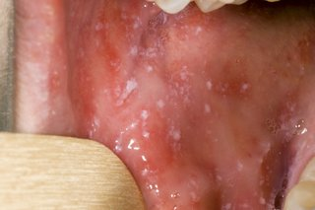
Small white spots may appear inside the cheeks and on the back of the lips a few days later. These spots usually last a few days.

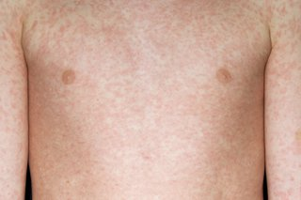
The measles rash
A rash usually appears a few days after the cold-like symptoms.
The rash starts on the face and behind the ears before spreading to the rest of the body.
Credit:
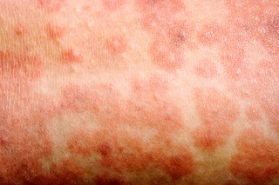
The spots of the measles rash are sometimes raised and join together to form blotchy patches. They're not usually itchy.
The rash looks brown or red on white skin. It may be harder to see on brown and black skin.

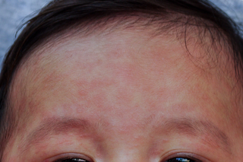
Around day 3 of the illness, a rash of flat red or brown blotches appear, beginning on the face, behind the ears and spreading over the body. The incubation period is between 10 to 12 days but can vary from 7 to 21 days.
Measles is highly infectious and transmitted via airborne or droplet spread, or direct contact with nasal or throat secretions of infected persons. Cases are infectious from 4 days before onset of rash to 4 days after, where the date of the rash onset is day 0.

What should you do if you think your child has measles?
You should ask for an urgent GP appointment or get help from NHS 111 if you think you or your child may have measles.
Don’t go to the GP or any other healthcare setting without calling ahead first.
If your child has been diagnosed with measles by a doctor, they should stay off nursery or school for at least 4 days from when the rash first appears.
They should also avoid close contact with babies and anyone who is pregnant or has a weakened immune system.

What is the best way to protect against measles?
The best protection against measles for children and adults is to get both doses of the MMR vaccine.
Children are offered a vaccine free on the NHS at 12-months-old and then a second dose when they turn 3-years-and-4-months-old.
But you can catch up at any age – if you or your child haven’t yet been vaccinated, you should contact your GP practice to book a free appointment.
You can request a version of the MMR vaccine that does not contain pork products from your GP, making it suitable for all faiths. Please note that the practice may need to order this product in specially, so it will be helpful to tell them your views before the appointment.

When should you keep your child off school or nursery and how long for?
If your child has measles, they should stay off nursery or school for at least 4 days from when the rash first appears, and avoid close contact with babies and anyone who is pregnant or has a weakened immune system. If your child is still unwell after 4 days they should stay off school until they feel better and have no temperature.
Please contact your school if your child has been confirmed with measles as they will have procedures to follow.
Anyone who has been vaccinated is unlikely to be considered susceptible.
If you’re not sure whether your child is due a vaccination or has missed a vaccination, you can check your Red Book or contact your GP practice.
If your child has missed their first or second dose of MMR vaccine, you should contact your GP practice to book an appointment.

Should you keep your child off school if another pupil has been diagnosed with measles?
Most children will be protected against measles and there is no need to keep your child off school if they have had both their MMR vaccinations.
Your school will contact you if your child has been in contact with someone with measles. It's very unlikely to be measles if you've had both doses of the MMR vaccine or you've had measles before.

Can I still get my child vaccinated even if they’re older?
Yes. Anyone who has not had 2 doses of the MMR vaccine should ask their GP surgery for a vaccination appointment.
It’s best to have vaccines on time, but you can still catch up on most vaccines if you miss them. Two doses of the vaccine are needed to ensure full protection.

LINKS
https://educationhub.blog.gov.uk/2024/01/22/what-to-do-if-you-think-your-child-has-measles-and-when-to-keep-them-off-school/

https://www.nhs.uk/conditions/measles/

